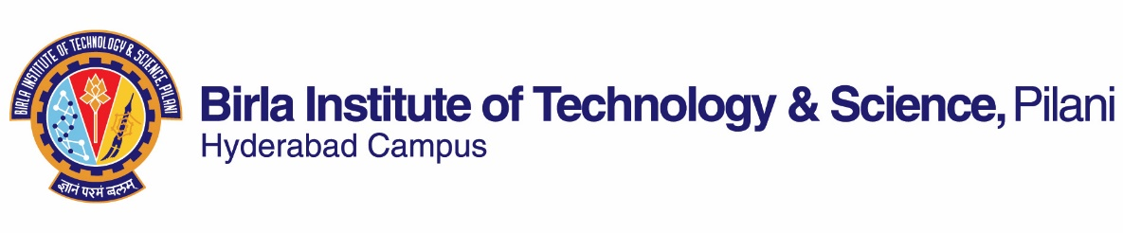

**SECOND SEMESTER 2019-2020**

# Course Handout Part II

Date: 06-01-2020

In addition to part-I (General Handout for all courses appended to the time table) this portion gives further specific details regarding the course.

*Course No.* : PHY F344

## Course Title : Advanced Physics Laboratory

## Instructor-in-Charge : Prof. Aravinda N. Raghavan

Co-instructors : Prof. V. Meenakshi, Ms. N. M. Aishwarya

**Scope and Objective of the Course:**

# In this course, the student will learn to think like a scientist where scientific inquiry, logical reasoning and learning scientific practices will be emphasized. To engage like a scientist and to be curious about physical phenomenon entails making observations, formulating questions, gathering evidence in a reproducible manner, making scientific claims based on evidence and modelling using existing scientific knowledge, communicating results, and revising the explanation or revisiting the experiment based on critique from the community. In essence, the goal is to formally introduce undergraduate students to research through an inquiry based approach.

**Learning outcomes:**

1. Design experiments for a hypothesis.
2. Demonstrate lab skills related to data collection and interfacing of instruments.
3. Provide scientific reasoning on all aspects of lab related activities.
4. Analyze and model data and estimate errors in measurement.
5. Document and present the scientific findings coherently

**List of experimental facilities:**

|  |  |
| --- | --- |
| **No.** | **Experiment** |
|  | Differential Scanning Calorimetry |
|  | Powder X-ray diffraction |
|  | Hall effect measurement |
|  | Forbidden band gap measurement |
|  | Thermo-gravimetric analyzer |
|  | Fourier Transform Infra-red spectroscopy |
|  | Zeeman effect measurement |
|  | Atomic force microscope |
|  | Dynamical Mechanical Analyzer |
|  | Low temperature electrical conductivity measurements |

**Evaluation Scheme:**

|  |  |  |  |  |
| --- | --- | --- | --- | --- |
| **Component** | **Duration** | **Weightage (%)** | **Date & Time** | **Nature of Component** |
| Design of experiments |  | 20 |  | Open |
| Basic lab skills, Data collection |  | 20 |  | Open |
| Modelling and analysis |  | 30 |  | Open |
| Weekly lab work and interaction |  | 10 |  | Open |
| Final report and presentation |  | 20 |  | Open |

**Chamber Consultation Hour:** None required

**Notices:** CMS and Physics notice board

**Make-up Policy:** It is applicable to the following two cases and it is permissible on production of evidential documents:(i)Debilitating illness(ii)Out of station with prior permission from the Institute.

**Academic Honesty and Integrity Policy**: Academic honesty and integrity are to be maintained by all the students throughout the semester and no type of academic dishonesty is acceptable.

**INSTRUCTOR-IN-CHARGE**